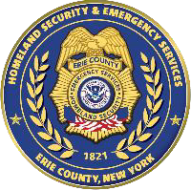


Essential Travel Business/Organization Checklist
This document contains guidance to help businesses/organizations effectively manage their employees during a major event in Erie County.
GENERAL TIPS
- Develop an Emergency Plan & Communications Plan.
- Stock your business with supplies (Food, Water, Blankets, Hygiene Kits) for essential employees who might be required to stay.
- Consider staffing for a multi-day event.
- Update your employees as information changes.
PRE-EVENT
- Communicate with your employees based on the pre-event information & reports.
- Identify which category your business falls within based off the “Erie County Guidance on Essential Travel” PDF.
- Define your essential employees that are contained within your selected category and identify employees who must report to work. Essential workers who are able to perform work remotely, should be allowed to.
- Provide your essential employees with business/organizational documentation (IDs) that properly list them as essential within your business/organization. Remember every event is different.
- Pay close attention to National Weather Service weather forecasting for your local area
DURING AN EVENT
- Follow Erie County’s directives released in the media and on official Erie County Channels as to what categories are deemed essential during an event.
- Be able to justify your work/travel during an event to law enforcement personnel. (Discretion and liability remain on the organization for their employees plus travel and access are at the discretion of public safety and does not exclude citation for violation.)
POST-EVENT
- Reevaluate your list.
- Review your plan(s) & restock supplies.

