Adding Captions and Transcripts to Media
It’s easier to create content that is Section 508 compliant than it is to retroactively correct it. Whenever you can, build accessibility into your content from the very beginning. Before you start recording your media, consider the following:

- What format are you using?
  - Audio-only media must have a written transcript included.
  - Video-only media must have a written transcript or audio description included.
  - Synchronized audio-visual media must have open or closed captions and audio descriptions (AD) included.
- What platform are you using to record the content? What platform are you using to edit the content? What platform are you using to share the content?
  - Whether you are using apps like Webex and Microsoft Office products, websites like YouTube, or more advanced tools like Premiere Pro, Resolve, Canva, iMovie, DaVinci, etc., most of the media production tools at your fingertips have built-in automated transcript or caption generation.
- Is there a script?
  - If you are working off a script for your recording, use that as the basis for your transcript file. Upload your text file (.txt) alongside your video for a transcript.
  - If the content isn’t based on a script, you will need to rely on the automated
- Besides captions and/or transcript, is the media accessible in other ways?
  - Consider if your media also needs audio descriptions added to it. If you include descriptive narration and presentation of data in the original file itself, you will not need to create a separate AD track on your video.
  - Avoid using quick cuts, flashing or strobing life effects, and any looping animation or videos that cannot be stopped, paused, or controlled by the viewer.

What is the difference between a transcript file and a caption file?
Transcription refers to the process by which audio is converted into written text. Transcriptions can be verbatim (word-for-word accounts that include all utterances and sound effects -- most beneficial for scripted speech) or clean read (texts edited to read more fluidly -- better for unscripted content like interviews and recorded speaking events).​
​
Transcripts are generally not time-coded, meaning viewers with hearing loss or cannot follow along with the content in real time.​ Caption files, however, are time coded – meaning the text is tracked with detailed text that has accurate time stamps (often every few seconds) synchronized with the audio as it is heard on video.
​
Transcripts can be used by people who can neither hear audio nor see video: refreshable Braille devices can translate a transcript into Braille so that deaf/blind people can understand them. Screen reader users may also favor a transcript over real-time audio, since the screen reader can be set to read at a rate much faster than natural human speech. Transcripts may also be preferred by people with learning disabilities because they can take as much time as they need to read and process it. Unlimited time to read is also helpful to English language learners, who can read through it at their own pace, or feed it into a translator app if they need to.

Captions files must be saved in a very specific format that video players can use to display the text, precisely tracked down to the millisecond, with the audio. Time coded captions meet ADA compliance because they allow viewers to follow along with the dialogue in real time. This provides an equivalent experience to people with hearing loss. All audio elements should be reflected in the written captions – this includes dialogue, narration, sound effects, music, and speaker identification.​

You may see the terms “transcription” and “caption” used interchangeably in this document or in your video editing software. Remember, it’s only a true caption file if it has the special formatting (VTT or SRT) and time coding.

What does a caption file look like?
Caption files can be created using the Notepad plain text editor included with Windows computers. The main differences between a transcript and caption file are that transcripts can be uploaded with your video as a .txt extension file, and time stamps or time codes are not needed, whereas caption files require very detailed and specifically formatted time codes uploaded as .vtt or .srt extension files.

Here is a sample of what time coding looks like in an .srt file format:
1
00:00:00,599 --> 00:00:04,160
>> ALICE: Hi, my name is Alice Miller, and this is John Brown

2
00:00:04,160 --> 00:00:06,770
>> JOHN: and we're the owners of Miller Bakery.

3
00:00:06,770 --> 00:00:10,880
>> ALICE: Today we'll be teaching you how to make
our famous chocolate chip cookies!

4
00:00:10,880 --> 00:00:16,700
[intro music]

Another viable format is .vtt format files – they start with a specific code in their headers (WEBVTT), and while SRT files use commas to represent milliseconds, VTT files use periods instead. VTT files support text positioning on the screen and have rich text encoding, meaning you can use text formatting like bold, italics, and underlining. SRT files are more basic and do not provide the stylistic features that VTT captions can.

Here is a sample of a .vtt format file:
WEBVTT
00:00:01.600 --> 00:00:05.427
In this video,
I'll show you how we can screen an Adobe

00:00:05.427 --> 00:00:11.203
PDF for ADA compliance to make sure that

00:00:11.203 --> 00:00:11.760
it is compliant to people that use screen readers.

00:00:12.320 --> 00:00:16.537
So, we're going to first test this
document for compliance and then I'll

00:00:16.537 --> 00:00:20.520
show you how we can use Adobe Acrobat Pro
to make some corrections.

Types of captions – Open or Closed
Open captions are a permanent part of the video that cannot be turned on or off – they are part of the video picture, and they will always be visible to anyone viewing it. This gives the media producer total control of the captions’ appearance (like their location, font, size, color, and timing). Closed captions can be turned on or off by the individual viewer, so viewers have more control over the appearance and application of these captions. ​

How to automatically generate captions & transcripts
To create accessible audio-visual media, follow these steps:

Record your media.
Use the recording tools at your disposal to capture your content or event. You can use a camera or a screen recorder—Erie County machines have recording capabilities through the Snipping Tool, Clipchamp, Webex (via Vidcast), PowerPoint, and more. Make sure that your audio input is captured properly by the microphone. Speak at a measured, natural pace and volume. Clearly annunciate your words and avoid saying “umms” and “ahhs” to fill dead air space.

For example, if using Vidcast, open Webex and locate your Vidcast video library from the left side menu.

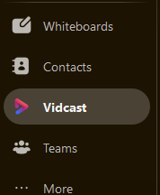

Make sure your Account Settings have auto transcript generation enabled before you start recording --this should be the default setting for Vidcast.

(Technically, make sure your auto transcript generation is not disabled)
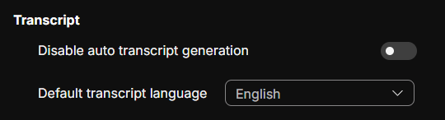

- Hit the purple New Video button in the upper right-hand corner of the screen to create a new video or a screenshare recording. If you want to record your Webex meeting, be sure to hit the circular Record Meeting button as soon as the meeting begins.

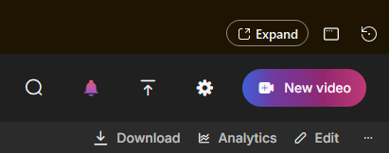

Upload your media to an editing software.
If you are recording in the same software you plan to edit, you have already completed this step. If your recording comes from a separate source, upload the video into editing software as you normally would.

Generate or Download the caption/transcript file
Once the video upload is fully complete, navigate to the Edit or Settings options on your platform. Sometimes this will be a button in the menu bar that simply says “Edit”, it could be an icon that looks like a pencil or pen, or in the case of Clipchamp, you can find this feature under the Video Settings menu on the right side panel of the page.

Webex / Vidcast
As mentioned in the previous section, your Vidcast account settings should have auto-transcription (in English) enabled by default. After the video has been recorded, you can view the transcript that was automatically generated by Vidcast from its speech-to-text translator.

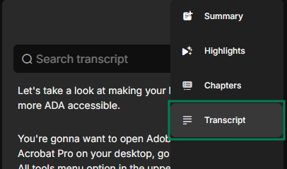

Copy or Download Transcript right from the video playback screen. This will copy the caption or save it in the appropriate VTT-formatted, time-coded file with proper text spacing.
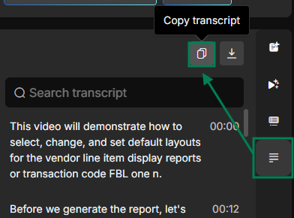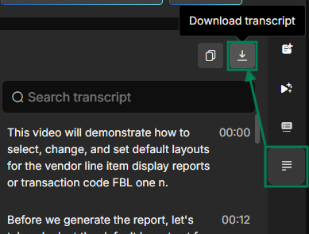

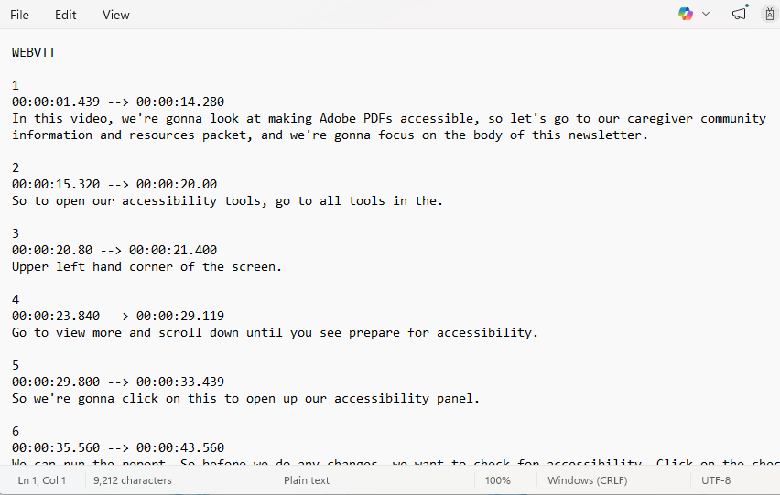

Clipchamp
Videos you record to your computer that you then upload to OneDrive will use Clipchamp for video playback, editing, and sharing.
- Open the video in the Clipchamp video playback viewer. Click the Video Settings button on the right side panel of your screen.
- Here, you can click the purple Generate button to have the software do the text-to-voice translation and time coding text synchronization for you. You can click the Upload button to import your own transcript file that was created outside of Clipchamp.

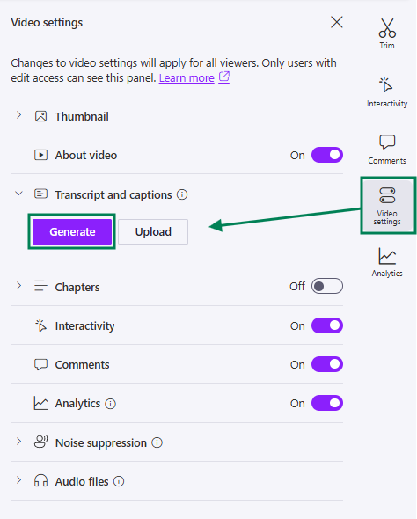

- A pop-up window will prompt you to confirm which language is primarily spoken in your video. If it all looks good, click on the Generate button in this window, too.

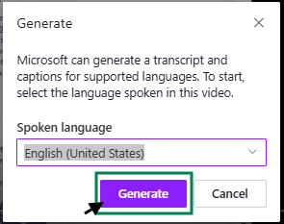

YouTube Studio

Here is a short and helpful video tutorial that walks through the process of downloading caption files from videos uploaded into YouTube: How to download your video subtitles from YouTube Studio. These steps are also written below.

- Log on to your YouTube Studio account for creators and go to the Content section (select this from the left panel menu).
- Locate and select your video from the channel content display.

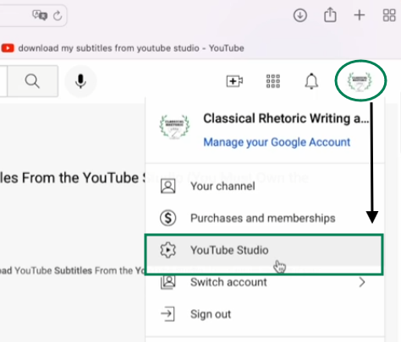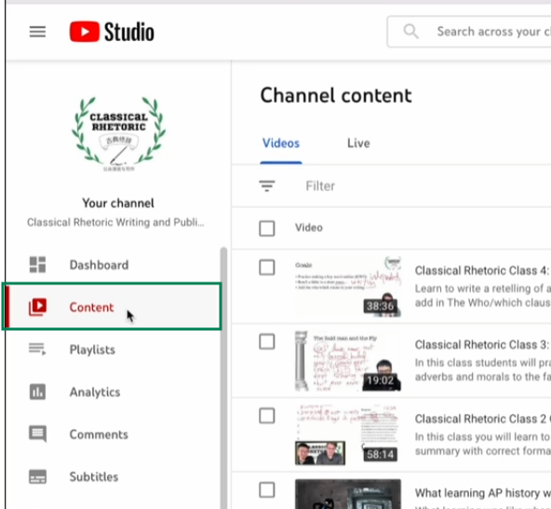

- With your video selected, look again on the left side of the page and locate the Subtitles tab in the menu. Click on it.
- Here, you can find the automatically generated subtitle file that YouTube creates for you. You can also upload your own independently created caption file. In this example, you would locate the English (Automatic) version.

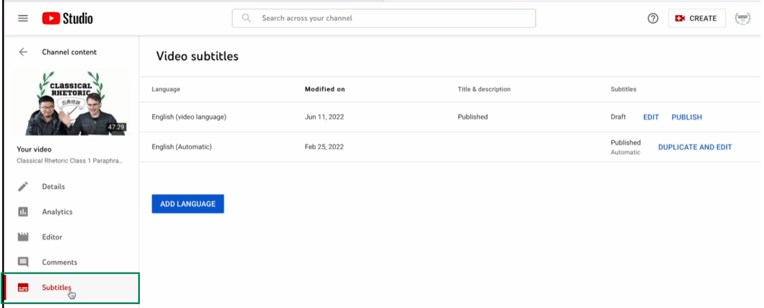

- Before you can download the subtitle file, it must first be published. Click on the blue Publish button next to your desired version— YouTube interprets the speech and generates speech-to-text timings during publishing.

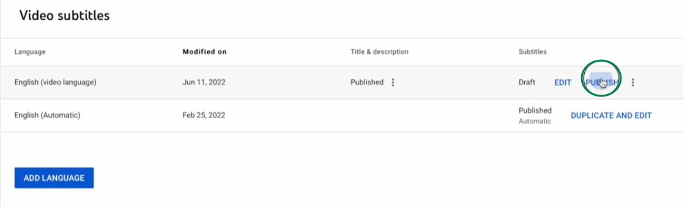
- Wait until the status under the Subtitles column changes from “Generating Timings” to “Published”. Once the captions have been published, click on the kebob menu () on the right of your subtitle file and click on Download to see your downloading options.

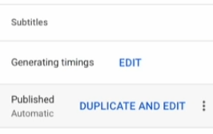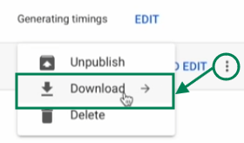
- Select the format in which you’d like to download your captions: .vtt, .srt, or .sbv. In this guide we’ve focused on the first two formats as they are the most common, but you should check with the compatibility that works best for your project’s needs. For example, Final Cut Pro uses .srt file formats for captions, so you’ll want to download this type of caption file.

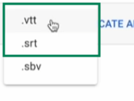

Review & Correct voice-to-text translation.
Play the recording while you read through the full transcript. Look for any errors that the automated transcriber might have made – misunderstood words, misspellings, missing words or significant punctuation errors. If you want a “clean read” transcript, this is your opportunity to make those minor edits to tidy up the text.

If you can, edit your transcript directly in the production software’s interface. This will ensure your changes are made to the original copy, so you only need to do this one time per video. Otherwise, download the VTT file and edit the document in Notepad or Word. Save the document (with the extension “.vtt”) and upload this edited copy with your video.

IMPORTANT: Do not assume the automated speech-to-text translations are 100% correct. Always validate and correct these automated captions before you download them.

Tip: speed up your video playback speed and scan the transcript text. If you notice a consistently misunderstood word or phrase, use CTRL+F to search for all instances of the error in your text.

Webex/Vidcast
If you want to make more wholescale corrections or updates, you will need to…
- Click on the 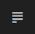 Transcript button from the playback page to expand the menu. Copy/paste or download as a .vtt file from the video playback page as described above.
- Read through the transcript. Make changes to the file in the word processor (like Notepad or Word).
- Save the updated VTT file.
- Upload the new version back into Vidcast: go to Edit > Edit Transcript > Upload VTT.

You can also make small corrections and updates directly in the Vidcast interface instead. If you only found a few typos or errors in your transcript that you must correct….

- Click on the Edit button in the upper right-hand corner of the screen.

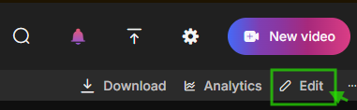

- Then click the Edit Transcript button on the right-side panel. On the opposite side on the page, to the left of the video playback window, the transcript will appear. Comb through the text for errors in the auto-transcription and correct it – be especially careful to correct mistakes the AI might have made which would change the meaning conveyed if not corrected.

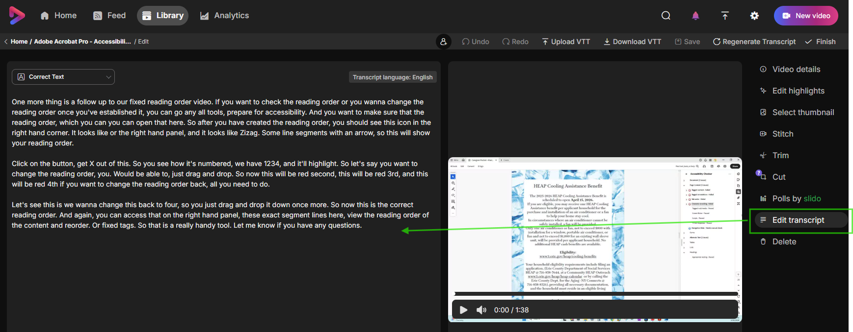

- Select the words that you want to correct one-by-one and edit them in the pop-up window. Note: in the Vidcast transcript editor, you can only update one word at a time.
- Save the transcript once you’ve made all the necessary changes, then click on the Finish button to return to the video library.

- Exit the video editor and return to the previous page. Download the edited transcript from the video playback page.

- Do not use the Download VTT button found under Edit > Edit Transcript: this caption file is not properly formatted (there are no spaces between any of the words).

- If you need to change the language of your transcript, you can overwrite the original transcript with a different translation by opening the video and clicking Edit > Edit Transcript > Regenerate Transcript. Select the new language and hit the Regenerate button.

Clipchamp
You might find it easier to read through the transcript in a word processor like Notepad or Microsoft Word. If so, you can make edits and save the document as an external file (under Transcript > Download).
- Download the transcript as a .docx- or .vtt-extension file.

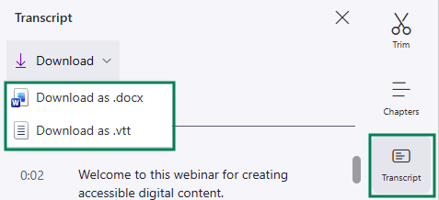

- Carefully read through and correct any spelling or content errors the automated transcriber might have made.
- Save the corrected copy of with a .vtt extension, then go to Video Settings > Upload to update or correct an automatic transcript.

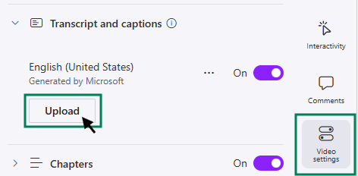

You can also read through and update the original time coded transcript right in the Clipchamp video editing interface.

- Click Transcript from the ride-side menu.
- Locate the segment you want to correct and click on it.
- Click on the Edit button that appears in the upper right corner of that chunk of text.
- Make your changes, then click on the Done button for each block of text you correct. The changes you make should save automatically to the transcript.
- Re-download your revised caption file.

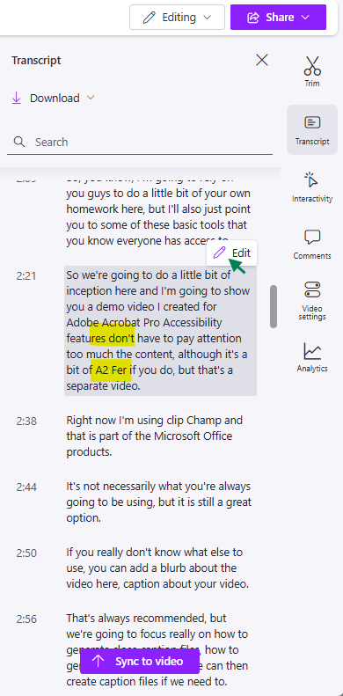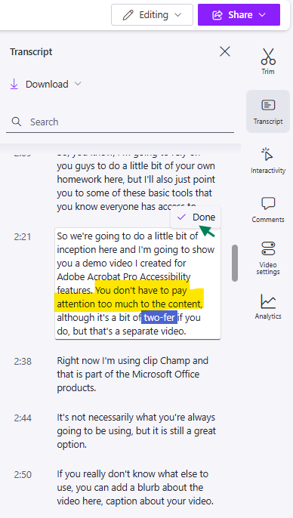

Note: Clicking the Sync to Video button will jump to the part in the video which matches the text you had selected when you clicked it. This does not update the transcript, but it will help you navigate and skip to different segments while you carefully screen and edit the text.

YouTube Studio
Like the other programs we reviewed here, YouTube Studio allows users to edit the caption text as well as the synchronization of time signatures directly in the platform/user interface. But, like the other applications, it’s better to download the captions from the video editor so you have your own long form, plain text copy to work with outside of YouTube’s interface.

- Download the time coded caption file from the subtitles you had previously published; make the updates you need; save the corrected copy.
- Click on Edit (or on the kabob menu) and locate the Upload option to insert your new, corrected caption file.

Download the video with your revised transcript.
Once you have verified the text of your transcript or closed caption file is correct, save the finished transcription with the appropriate file extension (caption files as .vtt or .srt; non-time coded transcripts as plain .txt). You can upload this transcript or caption file back into the same video editor.

You can also download the caption file and the video it was created from, so they can be shared elsewhere. Download the .MP4 video file to your computer or shared drive; save the transcript file in the same location, and don’t forget to add it to the video anywhere else it’s posted.

