ONRAB Ultralite
Information Sheet and Safety Guidelines

ONRAB
WILDLIFE RABIES VACCINE BAITS

Rabies Vaccine, Live Adenovirus Vector
For veterinary use only
For active immunization of wildlife against rabies

ONRAB rabies vaccine produced by Artemis Technologies Inc., an indirect, wholly-owned subsidiary of Ceva Sante Animale S.A., Guelph, Ontario, Canada, is a live virus, liquid vaccine. The vaccine was prepared by inserting the rabies glycoprotein gene into the genome of adenovirus Type 5.

The manufacturing and testing procedures used have been reviewed and approved by: the Canadian Centre for Veterinary Biologics (CCVB) and the Canadian Food Inspection Agency (CFIA). Both the cell line and virus used in the preparation of the product have been tested for freedom from extraneous viruses and have been approved for vaccine production.

ONRAB rabies vaccine is currently under evaluation for use in the United States by the USDA, APHIS, Center for Veterinary Biologics.

The vaccine is contained in a plastic blister pack which is coated with a fat/wax attractant ready for use. The vaccine contains the following antibiotics: Polymyxin B sulphate (15 Units/mL) and Neomycin sulphate (15 Units/mL). The bait matrix (attractant coating) contains approximately 100 mg of tetracycline hydrochloride.

Caution:

- The vaccine bait is intended for the oral vaccination of wildlife only and should not be administered to domestic animals.
- The vaccine virus, under normal conditions of use, is not considered to be pathogenic to humans or domestic animals. However, care should be taken when handling the bait to avoid direct contact with the vaccine. If exposure to the vaccine should occur avoid contact of the affected area with the mucous membranes (eyes, nose and mouth) and wash the affected area thoroughly with soap and water. Seek medical attention if needed.
- Exposure of the eye may result in adenovirus conjunctivitis: exposure of mucous membranes or broken skin may result in fever, sore throat, and headache (typical cold-like symptoms). The vaccine CAN NOT cause Rabies.

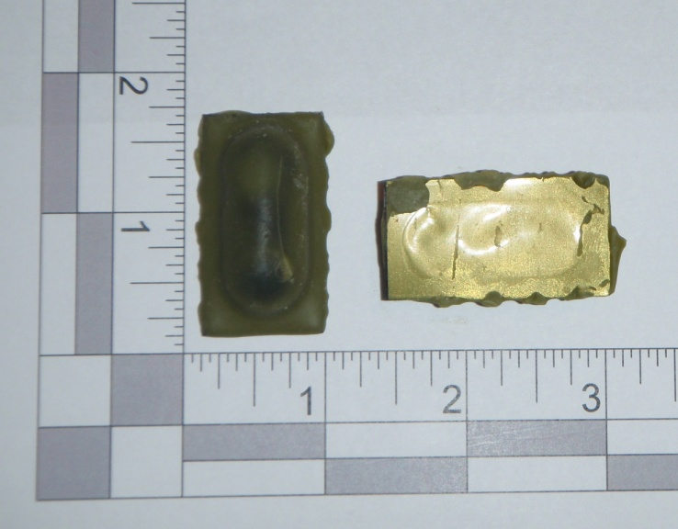
Bait Ingredients
ONRAB “Ultralite” Bait

The bait matrix coats the blister pack containing the vaccine and consists of hydrogenated vegetable fat, wax, icing sugar, vegetable oil, vanilla flavor and dark-green food grade color. Also included in the bait formula is tetracycline hydrochloride used as a biomarker.

Blister-pack (Vaccine Carrier)

The polyvinyl chloride (PVC) blister pack (1.57 in x 0.87 in x 0.39 in) contains approximately 1.8mL of the ONRAB vaccine and is sealed with a heat-sealable laminated polyester lidding. The body of the blister pack is coated with the bait matrix but the green lid is exposed and has a black warning label printed on it.

Dosage and Administration

ONRAB wildlife rabies vaccine baits are recommended for field vaccination of skunks, raccoons and foxes as a part of wildlife rabies control programs as an aid to the prevention of rabies in wildlife. Each bait contains a single dose of vaccine. Yearly vaccination is recommended throughout the control program.

Method of Administration

The baits are distributed either by hand placement or dropped from a low flying aircraft. Animals finding a bait will chew the blister pack and release the vaccine into the mouth which will orally vaccinate the animal against rabies.

Storage

Wildlife rabies vaccine (ONRAB) should be stored in the frozen state at a temperature of not higher than minus 20°C (minus 4°F). Unused wildlife rabies vaccine baits should be disposed of by incineration or autoclaving.

References

- Knowles, M. K., D. Roberts, S. Craig, M. Sheen, S. A. Nadin-Davis, A. I. Wandeler. 2009. In vitro and in vivo genetic stability studies of a human adenovirus type 5 recombinant rabies glycoprotein vaccine (ONRAB®). Vaccine 27 (20): 2662–2668

- Knowles, M. K., S. A. Nadin-Davis, M. Sheen, R. Rosatte, R. Mueller, and A. Beresford. 2009. Safety studies on an adenovirus recombinant vaccine for rabies (AdRG1.3-ONRAB®) in target and non-target species. Vaccine 27 (47): 6619-6626

- Rosatte, R. C., D. Donovan, J. C. Davies, M. Allan, P. Bachmann, B. Stevenson, K. Sobey, L. Brown, A. Silver, K. Bennett, T. Buchanan, L. Bruce, M. Gibson, A. Beresford, A. Beath, C. Fehlner-Gardiner, and K. Lawson. 2009. Aerial distribution of ONRAB® baits as a tactic to control rabies in raccoons and striped skunks in Ontario, Canada. Journal of Wildlife Diseases 45 (2): 363–374

- Yarosh, O. K., A. I. Wandeler, F. L. Graham, J. B. Campbell, and L. Prevec. 1996. Human adenovirus type 5 vectors expressing rabies glycoprotein. Vaccine 14 (13): 1257-1264

