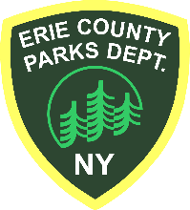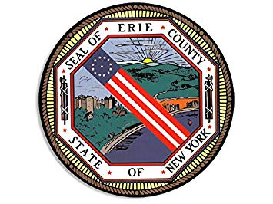

County of Erie

**Department of Parks, Recreation and Forestry**

**Commemorative Tree Application**

*Please complete this application and e-mail to* [***Erie_County_Parks@Erie.Gov***](mailto:Erie_County_Parks@Erie.Gov)*. Please review the Commemorative Tree Policy carefully prior to submitting your application.*

**Donor Name**  Click or tap here to enter text.

**Donor Address**  Click or tap here to enter text.

**Donor City, State, Zip Code**  Click or tap here to enter text.

**Donor Phone Number**  Click or tap here to enter text.

**Donor E-mail**  Click or tap here to enter text.

* **Which Erie County Park would you like your tree planted in?**  Click or tap here to enter text.
* **How many trees would you like to donate?** Click or tap here to enter text.

**Erie County Parks will add the name of the individual or event being commemorated to a designated section of our website. Commemorative trees may not be marked by plaques.**

* Please choose one:

This tree is planted “in honor of” Click or tap here to enter text.

This tree is planted “in memory of” Click or tap here to enter text.

This tree is planted “in celebration of” Click or tap here to enter text.

* Information about individual/event being commemorated (250 words or less)

Click or tap here to enter text.

* Who is this gift from?

This tree is a gift from Click or tap here to enter text.

You will be notified once your application is approved. Each commemorative tree is $500.00. Donations can be made by check or money order and made out to “**Erie County Parks Department**” and mailed to 95 Franklin Street, Room 1260 / Buffalo, NY / 14202. Please include a copy of this completed form with your check.

Once your donation is received, the tree will be ordered as soon as possible. You will be notified when planting is scheduled. Tree planting takes place during specific weeks in the spring and fall.

For any questions, please contact our office at (716) 858-8355.

**Rath Building • 95 Franklin Street, Room 1260 • Buffalo, NY • 14202 • (716) 858-8355 • Erie_County_ Parks@erie.gov**