Erie County Department of Parks, Recreation and Forestry
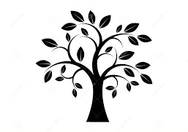
Commemorative Tree Program
The following individuals or events have been memorialized through the planting of a tree in our park system.

