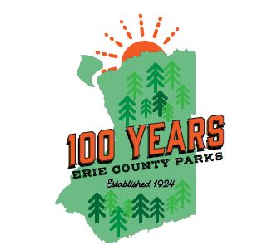

Erie County Parks Centennial Scavenger Hunt!
Erie County Parks is 100 years old this June! As part of our celebration, we have put together a fun, free, interactive Scavenger Hunt challenge for individual or family teams to enter! Earn at least 35 out of 100 possible points to earn a prize!

Here is how you start:
- Download the FREE Goosechase app
https://apps.apple.com/us/app/goosechase/id437330879

https://play.google.com/store/apps/details?id=com.goosechaseadventures.goosechase&pli=1

- Enter the Join Code or Experience Name
  - Join Code: ECParks100
  - Experience Name: Erie County Parks Centennial Scavenger Hunt

- Click on each Mission to learn about that task.
- Snap a selfie and upload it to that Mission to earn the point!
- If you’d like to Download the Mission list, you can do that, too!

