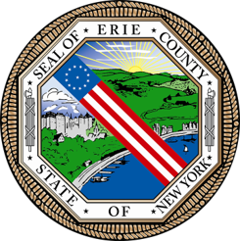
County of Erie
Department for the Aging

RFP# 2026-046VF

To: ALL BIDDERS
From: Erie County, Department for the Aging
Date: September 28, 2026
Subject: Addendum no. 2

DEADLINE EXTENSION: The attention of all bidders is directed to the following changes in the above RFP.

RFP# 2026-046VF The application deadline has been EXTENDED for existing Services Providers of Social Adult Day Programming to make submissions. The NEW Deadline for both electronic and hardcopy submissions is due by 4pm, Friday, October 23, 2026.

