ERIE COUNTY DEPARTMENT OF SOCIAL SERVICES
QUESTIONS & ANSWERS
RFP # 2023-001VF: Summer Primetime Programming
Questions submitted via email and at the Informational Meeting on January 25, 2023.
- Pg. 5 - #4 the OnBase Unity Form, I am not familiar with – is this a County based website?
It is is an Erie County web application that is used to submit the required RFP documents.

- Pg 6. - #17 Is the position of Language Access Coordinator expected/mandatory?
Yes

- Pg 7 – Year/Round Seasonal Activities – can include academic-based activities?
Yes

- Appendix A – under Cultural Competency – what do you mean by “intentional benefits/”
Intentional benefits would be positive outcomes as a result of deliberate actions taken to promote racial equity.

- If we are planning on collaboration with a school, would we have to provide data from the school as well as our agency??
Data is expected from similar work demonstrating the ability of all parties to meet the needs of the RFP.

- Previously our summer camp partners were able to apply for the same hours as Say Yes summer camp operation. Sites who wanted to operate camps extending beyond those hours were considered priority in the award process I was wondering if this was still the case.
An agency can utilize both funding sources, as long as monies are not claimed for the same expenses. Programs may receive a higher award if providing services additional hours or days of operations including weekends and/or evenings.

- How many hours are considered a full day program?
There is no set number of hours for a full day program. A shorter day would be expected to be really hands-on and jam packed.
- What is a "management" letter
A Management Letter is a statement of the auditor's comments and recommendations.

- We currently have 3 at risk schools requesting us to do programming. is cap of 15k still in effect PER APPLYING AGENCY or are we allowed to do per location? If the funding is received, are the enhanced expectations in order, even if only 5k / location?
There is cap of $15, 000 funding per agency and only one application is permitted per agency. Programs requesting more than $10,000 will be expected to provide services beyond the scope of the required criteria. This may include additional weeks of programming (more than six), additional hours or days of operations including weekends and/or evenings etc.

- Can you elaborate on a reference letter?
For agencies not previously contracted with ECDSS to provide the requested service, data is required from similar work demonstrating the agency’s ability to:
- review outcomes and meet performance measures
- maintain adequate staffing levels with trained staff
- meet required timeframes
- demonstrate leadership and proactive involvement in planning procedures
- communicate within the agency and with ECDSS
  - understand laws and meet regulatory expectations

- Can we combine funding hours with Say Yes?
An agency can utilize both funding sources, as long as monies are not claimed for the same expenses. Programs may receive a higher award if providing services additional hours or days of operations including weekends and/or evenings.

- Why aren't all agencies required to the COPS reports?
Only COPS eligible programs are required to submit the COPS reports. The COPS program began as a pilot program in 1988. LDSS COPS programs that were previously approved by OCFS and in operation on or before October 1, 2008, can submit a COPS plan to continue program operation and reimbursement.

- And it must be a non for profit ?
Organizations not part of a unit of local government must have their own 501(c)(3) status.

- Are enhanced expectations expected if the 15k is split between 2 or more sites?
There is cap of $15, 000 funding per agency and only one application is permitted per agency. Programs requesting more than $10,000 will be expected to provide services beyond the scope of the required criteria. This may include additional weeks of programming (more than six), additional hours or days of operations including weekends and/or evenings etc.

- Can you explain the type of insurance that is required by organizations to obtain and maintain?
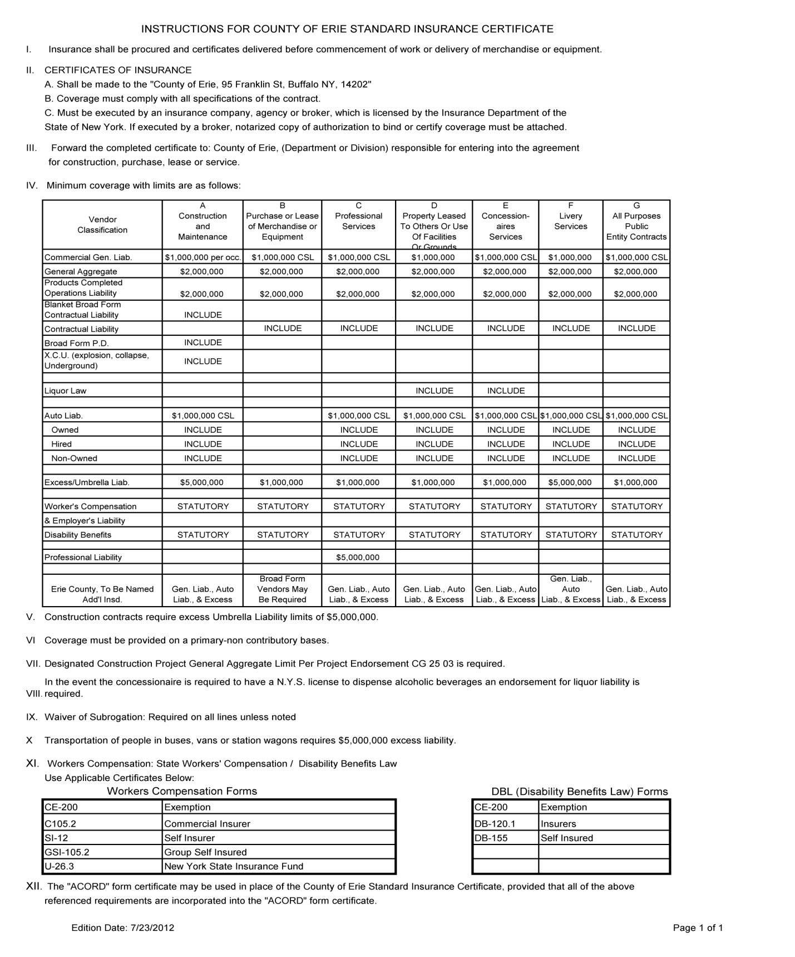
- Is insurance certificate sent in with application?
The insurance certificate is required at contracting.

- There are requests for additional documentation ie. various policies. Does the OnBase allow for those additional documentations to be uploaded?
Multiple attachments can be made per appendix.

- What date is the application due?
Feb 8, 2023 at 4pm

- How many uploads are allowed?
It is preferred to have one upload per Appendix, but additional attachments are permitted if necessary.

- Is there a number or email to contact if you have trouble?
Carrie Godfrey, (716) 858-6086, Carrie.godfrey@erie.gov

- How soon can we anticipate getting the slides & recording?
January 27, 2023

