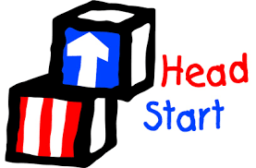
Community Development Institute
HEAD START
Serving Niagara County
North Tonawanda HS/EHS 1135 Oliver Street. North Tonawanda, NY 14120
Currently ENROLLING:
□ Income Eligible Children Ages Birth to 4
□Pregnant Woman □Foster Children
□Homeless Families □Children with Disabilities

Early Head Start/Head Start provides FREE
*Quality Early Childhood *Education *Healthy Meals/ Snacks
*Family Services Including Community Resources, Medical,
Dental, and Mental Health Education

To apply for Early Head Start/Head Start you can complete an online application by clicking on the link below:

English Application
or

https://www.childplus.net/apply/en-us/DD6D53A5B14BD02C39DEA365BA82653E/F930991CA41B995467A4125385429496

Contact Ms. Samantha or Ms. Danielle
@ 716-262-9919

To complete the application process, you will need the following:
- The child’s Birth Certificate
- Verification of family income, the past month’s income (pay stubs or employer’s statement)
or previous years income tax form (W-2 or 1040), or proof of currently receiving TANF, SSI
or Foster Care Payments.
- Proof of Residence (electric, gas, water bill, etc.)

“This Institution is an equal opportunity provider”

