

**Covid-19 Assistance Grant available with help paying Rent, Mortgage or Utility Bills.**

**Has to be Covid-19 related!**

C:\Users\Kim\AppData\Local\Microsoft\Windows\Temporary Internet Files\Content.IE5\0L0K4B01\MC900352394[1].wmf

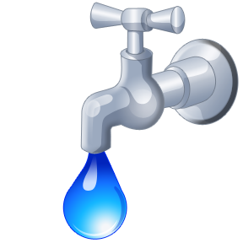

# To find out more information

### **Please contact an office near you:**

564 19th Street, Niagara Falls, NY 14301

**(716) 282-4375 ext. 124 or 126**

265 Falconer Street, North Tonawanda, NY 14120

**(716) 694-9727 ext. 129**

180 Washburn Street, Lockport, NY 14094

**(716) 433-6632 ext. 121 or 127**