au-some evenings
Once a month, our special Au-Some Evenings give children with autism spectrum disorder and sensory processing disorder, their friends and family an opportunity to play and learn together in an understanding and supportive environment. Families will have access to the museum space and play zones, including our cafe. Featured activities include a music center, therapy dogs, art projects and gross motor activities. Explore & More will also have a social narrative about the new museum and its play zones, quiet kits, as well as calming sensory friendly spaces in the museum.
Register and get additional information by visiting the website :
https://exploreandmore.org/au-some-evenings/

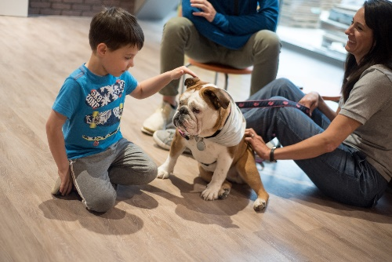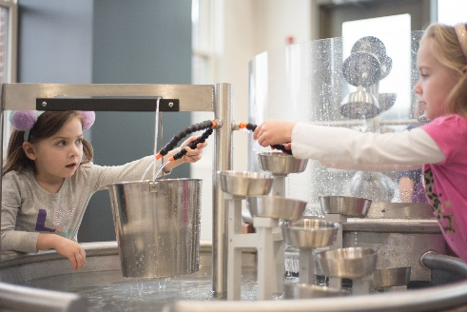
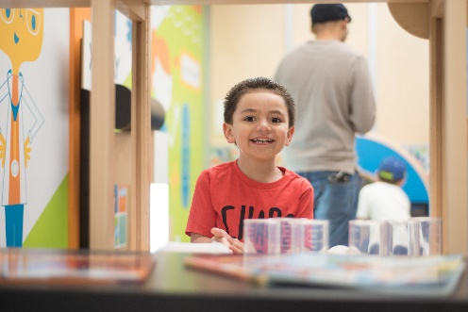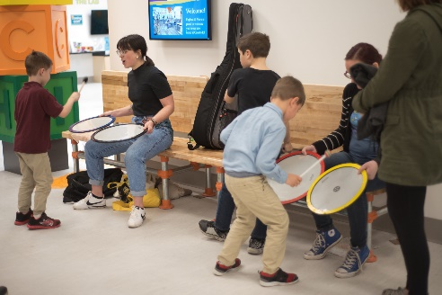
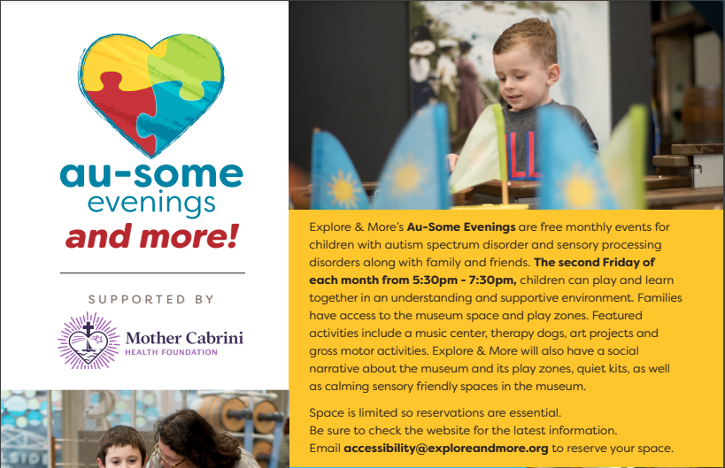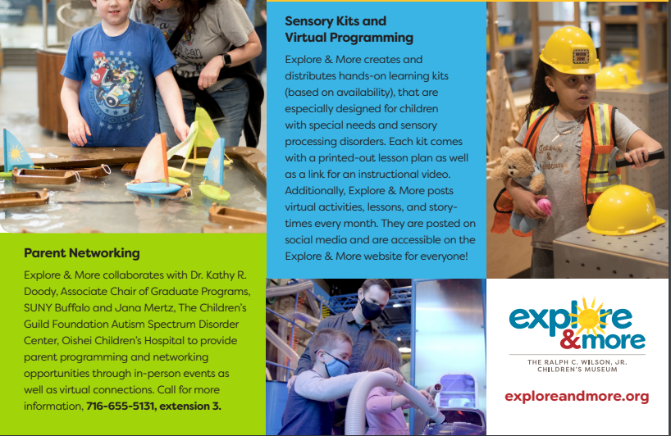

https://parentnetworkwny.org/
Parent Network offers so much – information, resources, training… Check out their website.
They have a ton of information and resources specific to Autism :  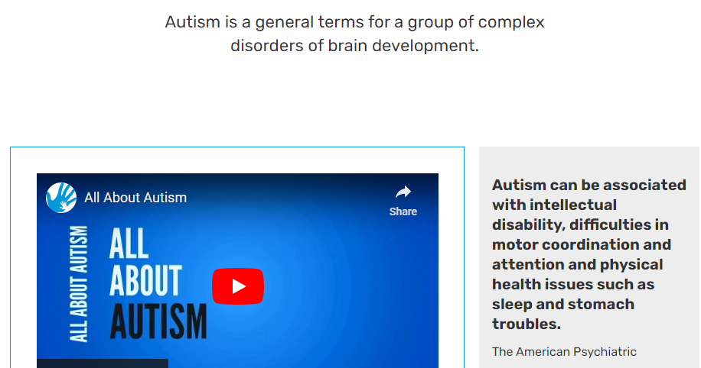  https://parentnetworkwny.org/autism/ | They provide informaiton and assistance in applying for OPWDD Services :  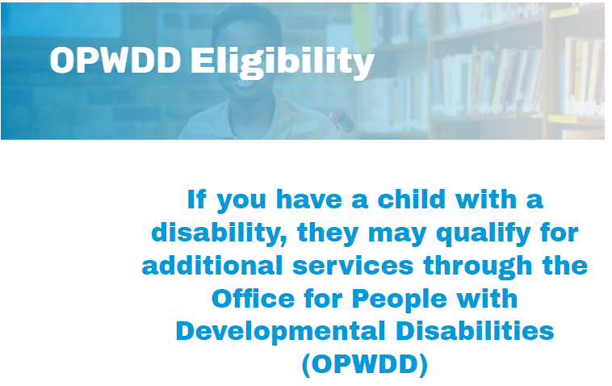  https://parentnetworkwny.org/opwdd-eligibility/
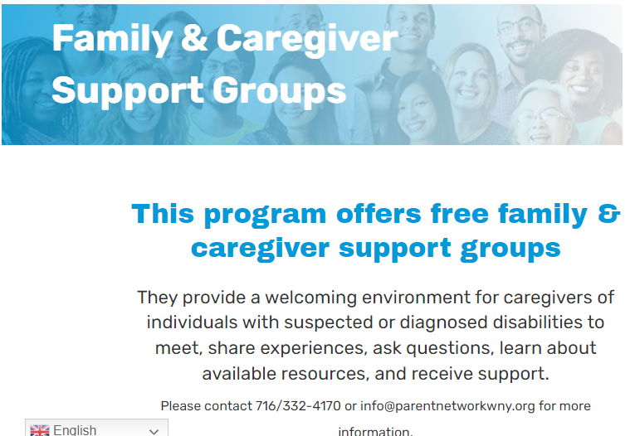  https://parentnetworkwny.org/family-and-caregiver-support/ | 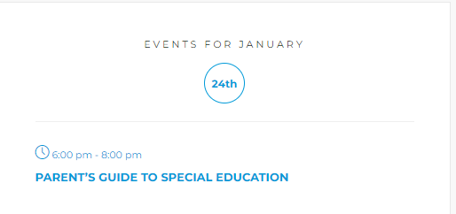  https://parentnetworkwny.org/events/

Support Group for Parents of Children with Autism - Parent Network of WNY
Aspire Building7 Community Drive Cheektowaga, NY 14225 parentnetworkwny.org/events/category/support-groups/
Jana Mertz
716-323-6435
Primary Services
Parent Support Groups
Description
Provides a welcoming environment for parents and other caregivers of children with autism spectrum disorders to meet, share experiences, ask questions, and receive support.
Childcare is available with prior registration; contact Kathy Doody at krdoody@buffalo.edu for more information. If interested in attending but facing transportation or other barriers that would limit participation, please contact.
Hours
Usually the 2nd or 3rd Wednesday of each month, 6:30pm-8:30pm; see website and click on community calendar for exact dates, or call for more information.
Eligibility
Parents and family members of children with Autism Spectrum Disorders.
Service Area: WNY.
Intake Process
RSVP in advance as space is limited. Sign up online, call, or email jmertz@kaleidahealth.org.
Program Fees
Free.
Contacts
Jana Mertz
Program Coordinator
jmertz@kaleidahealth.org

