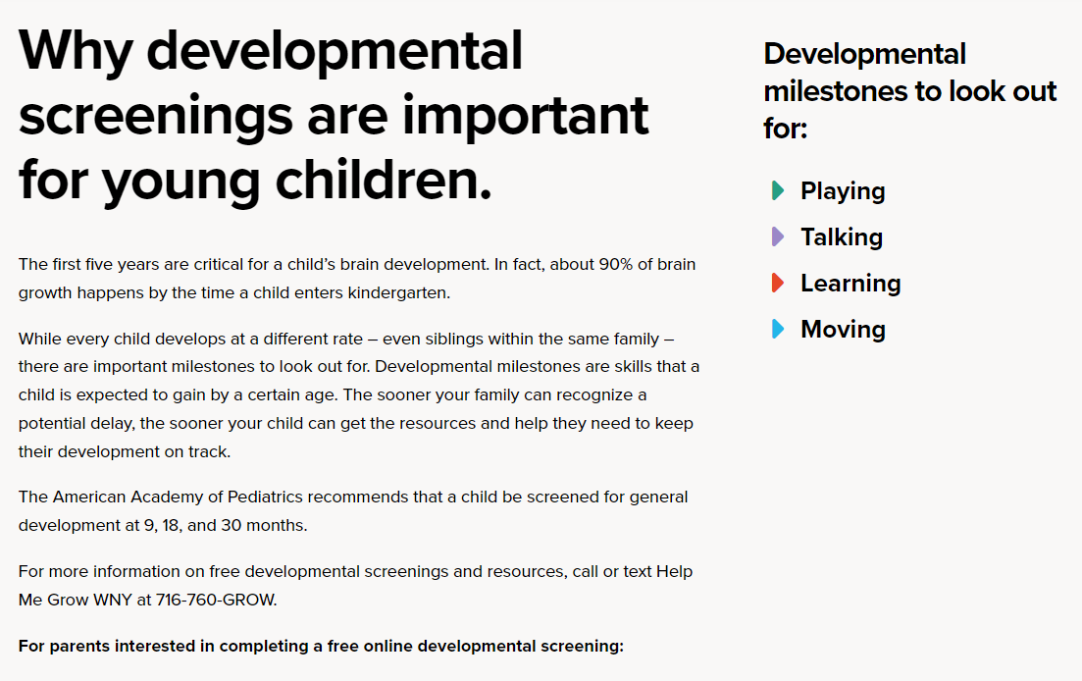

https://hmgwny.org/parents/